Fundamental of Programing

Lab Manual # 04

Lab Task

**Course Instructor:** Dr Talha

**Lab Instructor:** Muhammad Affan

## Student Name: Haseeb Tahir

## CMS ID: 453901

# Lab Task:

**Write a program in C++ to find the sum of first 10 natural numbers.**

#include<iostream>

using namespace std;

int main()

{

int answer;

for( int i = 1; i<=10; i++)

{

cout<<"enter the numbers"<<endl;

cin>>i;

answer += i;

cout<<answer<<endl;

}

}

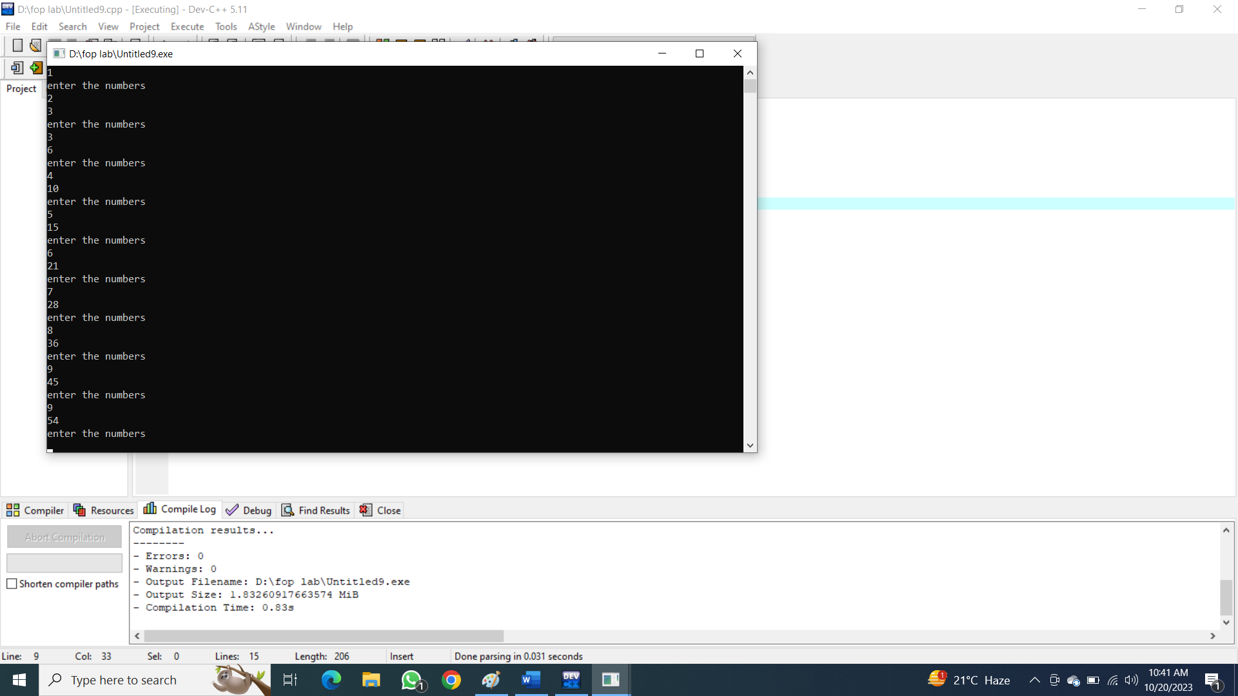

**Write a C++ program to Print a Table of any Number.**

The output should look like this:

#include<iostream>

using namespace std;

int main()

{

int table = 9, a=0;

for(int b = 0 ; b<11 ; b++ )

{

int result = 9*b;

cout << table << "*" << b <<"=”<< result<<endl;

}

return 0;

}

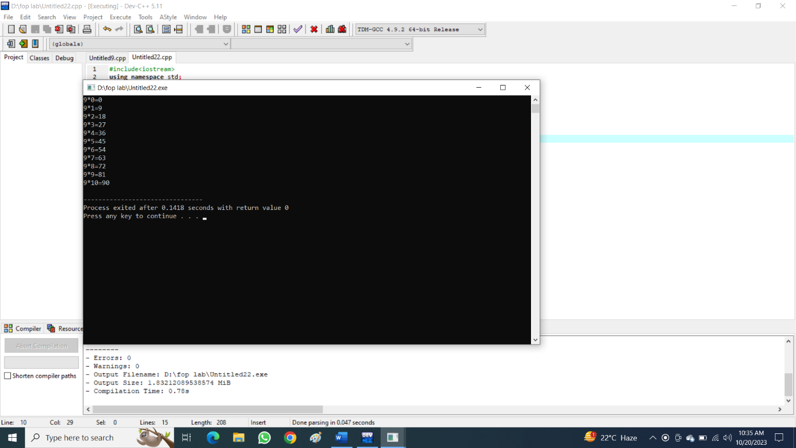

**Write a Program to Generate Factorial. A Certain Number Factorial of any number is the product of an integer and all the integers below it for example factorial of 4 is: 4! = 4 * 3 * 2 * 1 = 24**

#include<iostream>

using namespace std;

int main()

{

int a, factorial = 1;

cout<<"enter the value of a to find factorial"<<endl;

cin >> a;

for(int b = 1; b <= a; b++ ){

factorial = factorial*b;

}

cout<<"the factorial of given number is "<<" num!= "<<factorial<<endl;

}

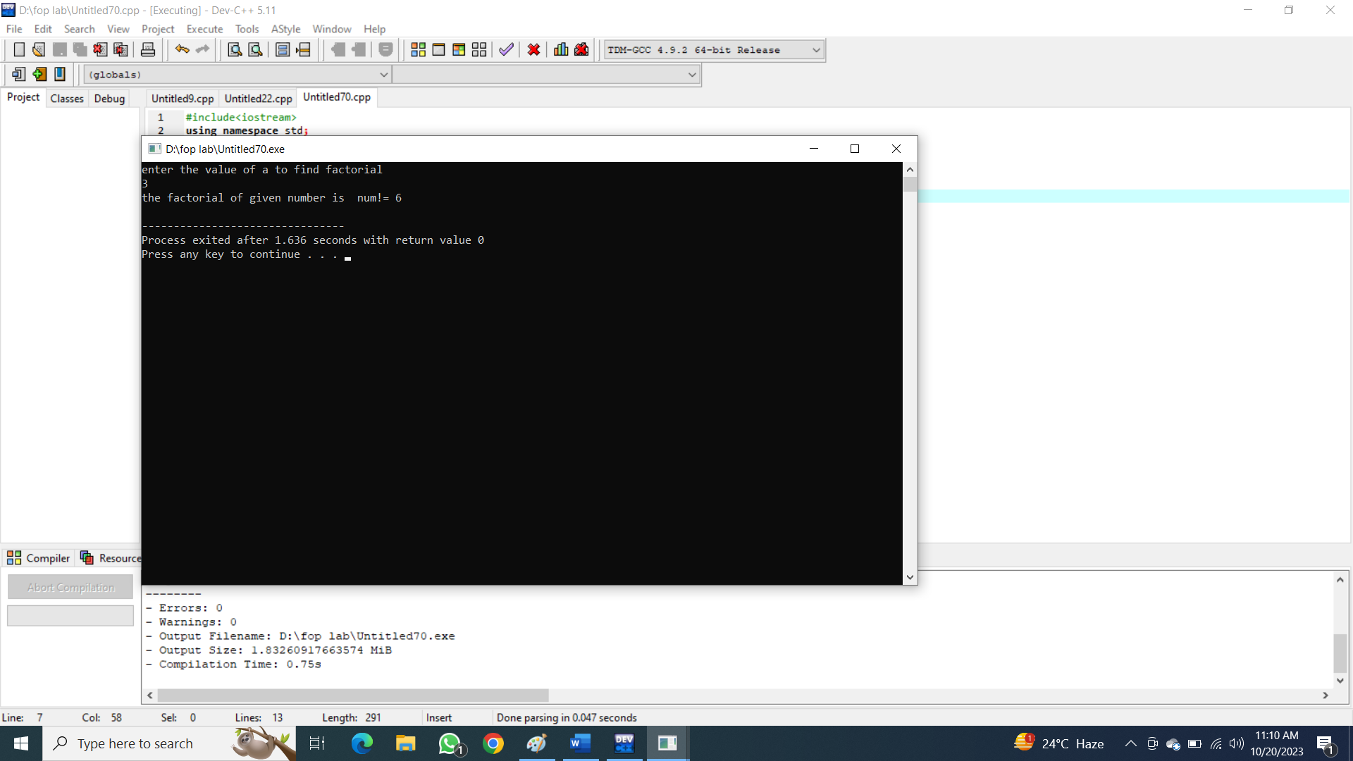

**Write a C++ program to generate a Fibonacci sequence up to a certain number input by the user.**

#include<iostream>

using namespace std;

int main()

{

int num = 0;

cin >>num;

int alpha = 0;

int beta = 0;

int secondnum = 1;

cout << num <<" ";

for(int a = 0; a < num; a++)

{

beta = num;

num = secondnum;

secondnum = (beta + secondnum);

cout << num << " ";

}

return 0;

}

